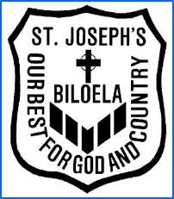
St. Joseph’s
Catholic Primary
School Biloela

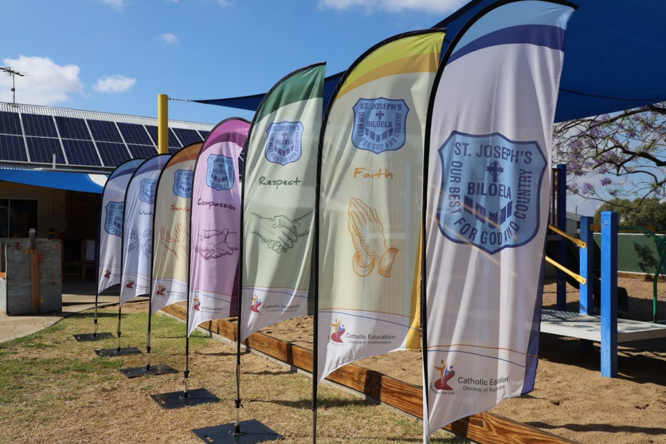

Parent Handbook 2022

Welcome

The St Joseph’s Catholic Primary School welcomes you to our school community. As a family of St Joseph’s School you have a vital role within our community. It is the collaborative partnership between school and home that ensures the best learning environment for the children.

St Joseph’s School was founded by the Sisters of Mercy and officially opened on the 31st January, 1939. This unique community of faith engendered by the Mercy Sisters continues today in an ever-growing atmosphere of faith, prayer and worship. The success of the school is attributed to the close, complementary relationship enjoyed amongst the staff, the students, the parents and the parish community.

Biloela (Aboriginal for Cockatoo) is situated in the Banana Shire at the juncture of the Callide and Dawson Valleys. The town combines a myriad of industry with both agricultural and large industry operations.

We look forward to working with you as ‘we journey with Christ in our everchanging world’.

May your experiences with us be rewarding and life-giving for our students and yourself.

Tina Knight
Acting Principal 2022
(for and on behalf of St. Joseph’s Catholic School community)

ST JOSEPH’S CATHOLIC PRIMARY SCHOOL
St Joseph’s Catholic Primary School, Biloela, provides for the students from Prep to Year Six. The school seeks to provide the students with a high-quality education, based on the living values of Jesus as expressed in the Gospels.

St Joseph’s Catholic Primary School seeks to give expression to the needs and vision of the parish community. While the prime responsibility is to the Catholic children of the parish, subject to space and the terms of the school’s enrolment policy, children of other faith traditions will be invited to share in the school community.

St Joseph’s Catholic Primary School seeks to develop the wholeness of the child in all aspects of his/her growth. These aspects of growth include the physical, emotional, intellectual and spiritual and cover a sense of social responsibility and a sense of justice.

The values of Jesus as expressed in the Gospels include:
Love and Reverence for the Creator,
Concern for the welfare of others,
Serving rather than demanding service,
Honesty,
The importance of truth,
The love of beauty and
The virtues of doing OUR BEST FOR GOD AND COUNTRY.

St Joseph’s Catholic Primary School recognises its role as a local identity in the community and responds enthusiastically to the needs and activities of the local area. In cooperation with the parents, it is hoped that the children will grow towards a faith commitment, which will prepare them to become valuable members of society.
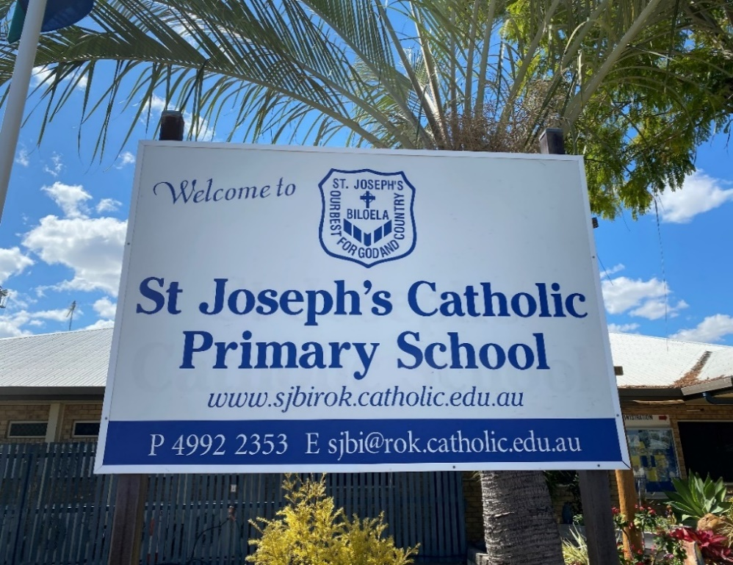

SCHOOL PROFILE

St Joseph’s Catholic Primary School, Biloela was founded in 1939 by the Sisters of Mercy, a Catholic teaching order of nuns founded by Catherine McAuley. The Sisters of Mercy maintained a leadership role at the school until 1980 when the first lay principal was appointed. The unique community of faith engendered by the Mercy Sisters continues today in an ever-growing atmosphere of faith, prayer and worship. The success of the school is attributed to the close, complementary relationship enjoyed amongst the staff, the students, the parents and the parish community.

Our school is a parish school, and as such the school leadership team maintains open lines of communication with the wider parish community. The Parish Priest and a member of the parish are members of the School Board, while the Principal is a member of the Parish Finance Committee and Parish Pastoral Council. These arrangements ensure that two-way communication takes place.

The school has an active policy of inclusivity and children with identified needs are accepted into the school after it has been established that the school is able to cater for their needs. Parents are encouraged to be involved in school life at all levels, including assisting in classrooms, School Board and Parents and Friends Association.

The school enrolment is approximately 150 children. There is one Prep group and six primary classes. The teaching staff is comprised of 10 class teachers; Principal; Assistant Principal Religious Education; Assistant Principal Curriculum, both of whom also have teaching responsibility; Learning Support Teachers, an Arts teacher and other specialist teachers taking release. Other staff members include a host of ancillary staff.

St Joseph’s School Board is responsible for the school policies, which provide guidance for the procedures implemented within our school.

At St Joseph’s we recognise that the only experience of church for many families is the experiences they have as a consequence of their involvement with the school. Therefore, we attempt to provide relevant and contemporary experiences as well as traditional parish-based experiences. The children attend Mass generally three or four times a term and other times throughout the school year.

Thank you for your interest in St Joseph’s. As a Catholic School we attempt to foster an environment of Christian love and understanding, a place where children and adults can grow in the knowledge of God’s love for them, and in love and concern for others. We look forward to having the opportunity to work with you, for we believe that education is a partnership between the child, parents, teachers and the whole community.
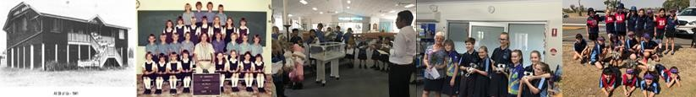

MISSION STATEMENT

St Joseph’s School exists to provide quality Catholic Education.
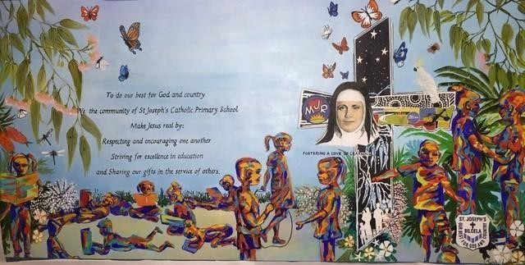

To do our best for God and country,

We, the community of St Joseph’s Catholic
School

Make Jesus real by:

Respecting and encouraging one another
Striving for excellence in education and sharing our gifts in the service of others.

VISION STATEMENT - Foster a love of learning

St Joseph’s Vision and Mission Statement

St Joseph’s Biloela is centred on Jesus Christ and the values that he embodied in his life, death and resurrection.

The key messages of our Vision/Mission Statement are:
As a school community, each and every day, we strive to:
- be the best version of ourselves.
- see the spirit of Jesus in each other.
- Make Jesus Real, in everything we do.
- encourage a love of learning.

At St Joseph’s we live our Mission and Vision Statement everyday

From Leadership
- Active involvement in our school, parish and wider community
- Regular mass and hymns
- Learning is relevant, student centred, hands on
- Symbols of the Mercy sisters around our school

From Staff
- Leadership groups
- Staff and students are active participants in learning
- Daily prayer as a school
- Care for our school environment
- Whole school projects
- Making Jesus Real is a way of life
- Virtue of the week
- Prep/Year 6 buddies
- Kindy/Year 5 reading buddies

SCHOOL PRAYER

This is our school let peace dwell here
May the rooms be full of contentment
may love abide here
love one another love mankind love life itself
for the love of God.
Let us remember that as many hands build a house
so many hearts make a school.

SCHOOL SONG

This is our school

CHORUS This is our school, let peace be found here,
May the rooms be full of happiness,
Let love abide, Love for one another
The love of life itself oo-oo-oh
And the love of God.

- Everybody knows that many hands are needed,
If you want to build a house, but to build a good school there’s a very simple rule:
What you need isn’t hands but hearts
So Lord, a blessing we ask of you.

- Everyone is special, everyone’s important in St Joseph’s School
Doesn’t matter at all if you’re big or small,
Being fair to each other, that’s the rule!
So Lord, a blessing we ask of you.

- Just like the river, flowing to the ocean we are flowing into God;
So let peace be the way as we live and work today, As we wander in the tracks you have trod,
Yes Lord, a blessing we ask of you.
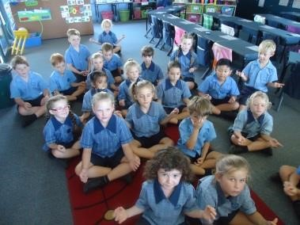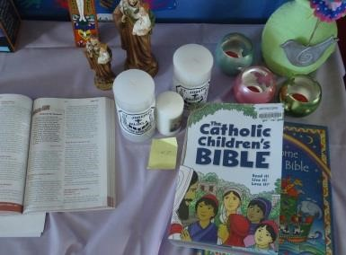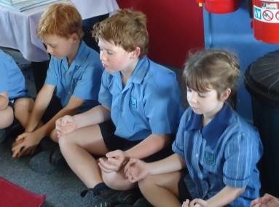

SCHOOL DIRECTORY

St Joseph’s Catholic Primary School
66 Rainbow Street
BILOELA Q 4715

Postal Address: | PO Box 157, Biloela Q. 4715
Phone No: | (07) 4992 2353 or 4994 8310
Email Address: | sjbi@rok.catholic.edu.au
Website: | www.sjbirok.catholic.edu.au
Parish Priest | Fr Simeon Uchendu
Acting Principal | Mrs Tina Knight 0417113170
Acting APRE | Miss Renee Maliborskij 0417142120
APC | Mrs Sally Hagley 0409865679
Financial Officer | Mrs Bernadette Brosnan
Administration Officer | Mrs Emma Dodson/ Mrs Jo Boothby
P & F ASSOCIATION 2022:

President Mrs Marnie McGrath
Vice President Mrs Kim Kingsnorth
Secretary Mrs Naomi Newton
Treasurer Mrs Kate Adornato

ST JOSEPH’S SCHOOL BOARD 2022:
Parent Members:
Ryan Harth (Chairperson)
David Hall (Secretary)
Natalie Gillies
Tanya Summers
Marnie McGrath
Parish Member: Pam Brosnan
Teacher Representative: Michelle Nsair
Faith Representative: Renee Maliborskij
Acting Principal: Tina Knight
Parish Priest: Fr Simeon Uchenda
STAFF 2022

Monica Chapman / Michelle Nsair | Prep
Lori Guest | Year 1
Georgia Wright | Year 2
Collette Stone / Diana Hammond | Year 3
Amy Brown | Year 4
Lauren Hitchen | Year 5
Tania Bode / Katie Greenhalgh | Year 6
Sally Hagley | Learning Support Teacher
Michelle Nsair  Rhana Maher | The Arts  WHS
Sue Chalk | LST – Learning Support Coordinator
Bernadette Brosnan | Financial Officer
Emma Dodson | Administration Officer
Sonya Heid | Library
Katrina Anderson | Library / IT
Helan Ambrey | Teacher Assistant
Joanne Boothby | Teacher Assistant
Janelle Bowkett | Teacher Assistant
Petrina Halberstater | Teacher Assistant
Silke Meyer | Teacher Assistant
Tracy Naish | Teacher Assistant
Marnie McGrath | Teacher Assistant
Katie Muller  Kaylene Howard  Meghan Wilton | Teacher Assistant  Teacher Assistant  Teacher Assistant
Nathan Tumaru | Groundsman
Julie Davies | Cleaner
Beccy Schibrowski | Tuckshop Co-ordinator
Louise Dittman | St Joseph’s Catholic Kindergarten Director / Administration
Amy Drake | St Joseph’s Catholic Kindergarten Teacher
Laura Edwardson | St Joseph’s Catholic Kindergarten Assistant

ORGANISATION & PROCEDURES
ARRIVAL
Students are asked to arrive after 8:15 am in the morning as a teacher is not on duty until this time. Students are to put their bags on their classroom port racks and then immediately move to the covered area.

ASSEMBLY
One assembly is held each week on Monday afternoon. The purpose is to enable us to gather as a community to pray, greet, to inform and to celebrate as one.

Monday Afternoon – 2:15pm in the undercover area.
- led by the year 6 students
- school prayer
- introduce virtue of the week
- messages
- birthdays
- awards
- national anthem

MOBILE PHONES
Students are only permitted to have a mobile phone at school if a parent / guardian has written a note giving the child permission to have it. The phone must be handed to their class teacher during the school day.
There is a school phone for students to contact their parents during the day if necessary. If students need to have a phone for before or after school, and they follow the procedures as outlined above, there is no concern.

SCOOTERS AND BIKES
All students are required to demount their form of transport once they reach the school gates. They must carry their scooter or push their bike through the school grounds, and then park them at the bike racks.

BUS ROLL
Each morning the bus roll is taken and students catching the bus are added to the bus roll.
It is appreciated if parents communicate to their child if they are catching the bus each day as this assists in the bus process.

CALENDAR
 | 2022 TERM DATES
Term 1 | 24 January - 1 April | 10 weeks
Term 2 | 19 April - 24 June | 10 weeks
Term 3 | 11 July - 16 September | 10 weeks
Term 4 | 4 October - 2 December | 9 weeks

CLASS ROLLS
Students arriving after 9:00 am in the morning need to collect a late slip from the office to take to their teacher. Students leaving from afternoon tea onwards are marked as absent for the afternoon session.
Students attending sports carnivals or event associated with the school are marked present for the day.

STUDENT PROTECTION
Every person in our school community has the right to feel safe. Any action which threatens this safety, causing physical, psychological or sexual harm is considered to be extremely serious.

Any reports of harm are to be referred directly to one of the two student protection contacts (Mrs Tina Knight – Acting Principal, Mrs Sally Hagley – Assistant Principal Curriculum and Mrs Sue Chalk – Learning Support Teacher). Student protection posters are in every classroom / administration / library area with the student protection contacts clearly labelled on them.

Clear guidelines and procedures have been formalised by CEO. Each teacher is familiar with the student protection policy and relevant guidelines / procedures. These are available for viewing from or discussion with the principal.

CLEANING
At all times the whole school (including every classroom) is to be kept neat and tidy. It is the responsibility of the staff and students to ensure papers etc are picked up around the school. At the end of each day students’ belongings are to be picked up and taken home. Classrooms are cleaned once to twice a week. Teachers are asked to put their chairs up according to the cleaning roster.

It is the classroom teacher and relevant students’ responsibility to ensure that port racks, classrooms and other external areas are kept clean and tidy.

The toilets and high traffic areas are cleaned every day.
Mrs Julie Davies is the school cleaner.

COMMUNITY RESOURCE CENTRE
The school has an annual subscription to the Community Resource Centre in Rainbow Street. The centre has many educational resources, kits and a variety of equipment that is used regularly by the staff at St Joseph’s School.

MESSAGE BASKET
Each class has their own designated message basket. Messages given to the office or from the office are distributed via the basket system. The classroom teacher plays a key role in this process as they ensure messages are given to students.

MEDICATION
Prescribed medication will be administered as directed by the child’s doctor or as set out on the original bottle label by the pharmacist. Where children are required to take medication a “Letter of Authorisation” must be completed. Panadol or other non-prescription medicine cannot be administered under any circumstance.

Please Note: We cannot administer the 1st dose of any medication.

Any medication to be administered must be taken to the office to be kept in a secure area. Only trained staff or leadership team members can administer medication.

PLAYGROUND EXPECTATIONS
All teachers are allocated to a playground duty. Teachers have been provided with clear guidelines to follow while on duty.

ACCIDENTS / INJURIES
Parents will be contacted as soon as possible when their child has been involved in an accident during the day. There are first aid officers within the school who will assist the student until parents arrive.
Minor Injuries – first aid officers assist the child.
Serious Injuries – the ambulance is called first, parents straight after the ambulance and the child is assisted by the first aid officer while waiting for the ambulance and their parents.

SCHOOL RESOURCE CENTRE - SCHOOL LIBRARY
Every effort is made to have the Resource Centre open to the children as often as possible. All students must use library bags to borrow and return books. Library bags are available from the school office all year at $11.00 per bag.

DAMAGED LIBRARY BOOKS
All students are responsible for ensuring library books are kept in good condition. Parents will be expected to pay a fee to replace damaged library books.

Parents will be notified if their child’s book is returned damaged. All monies are to be paid to the school office.

SCHOOL TIMES

8.35 am |  | Day commences
10.35 – 11.05am |  | First Break
1.05 – 1.35 pm |  | Second Break
2.55pm |  | End of school

SECURITY
The school has installed a security system that operates in the whole school. The system is monitored by State Government Security Services. Any incidents are signalled to them, and a local security company responds.

SICK CHILDREN
Children complaining of ill health are sent to the office at the class teacher’s discretion and parents will be contacted and asked to collect their child. The administration staff are first aid officers and other staff members have their first aid certificate.

HEALTH RECORDS
At the beginning of each school year, it is important that parents inform us of any changes to children’s health records, emergency contacts etc. Please keep us informed of changes as they occur. In the event of an emergency or accident the decision we make will depend upon the information which you have provided.

INFECTIOUS DISEASES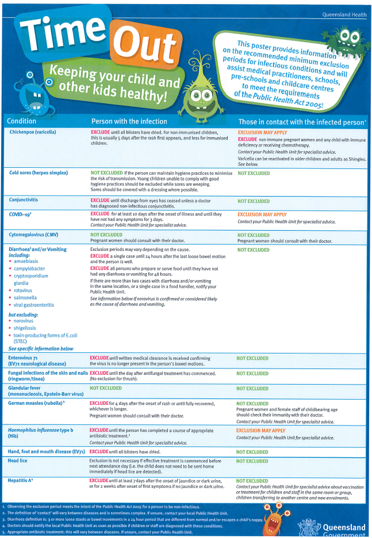
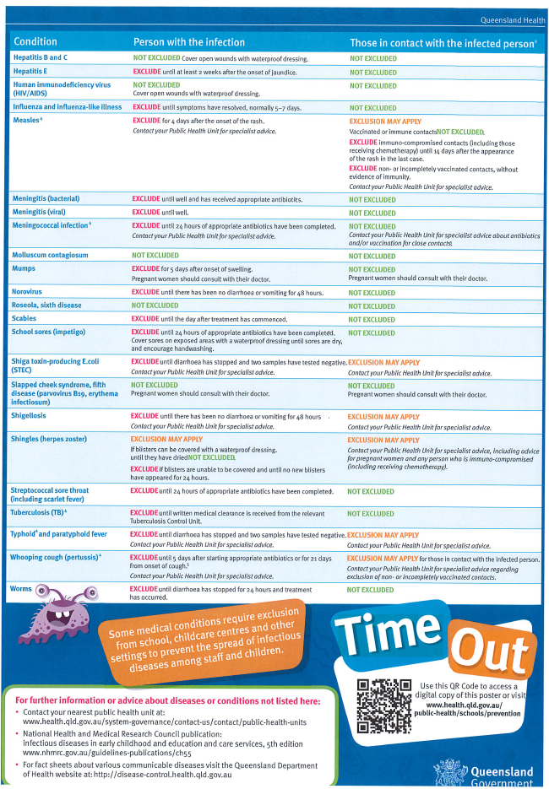

ABSENTEEISM
Parents are asked to notify the school by Parent Lounge, email or a phone call to the school office if their child is sick. Parents will be notified by the school if students are absent without notice.

EARLY DEPARTURE
Parents are requested to notify the school whenever their child is to leave or return to the school premises during school hours. Students must be accompanied by their parent or guardian and signed in or out through the school office.

PARKING
Parking is very limited around the school grounds. Please ensure the bus zone and driveways are kept clear. Students who have to cross a road to get to their family car must use the school crossing.

STUDENT AWARDS
Every Monday afternoon students are presented with awards for the good deeds they displayed during the previous week. Awards can be presented for (but not limited to) such things as: achievement, effort, manners, behaviour, good deeds, success and following the virtue of the week.

The purpose of these awards is to acknowledge all of the students at the school for their great work and encourage them to continue with their positive decisions.

Parents are to notify their child’s classroom teacher if they wish to be made aware of their child receiving an award prior to the event.

STUDENT LEADERSHIP
School Captains are selected from the Year 6 class. Other students will be selected as Captains of each of the House Colours. These colours are: Greycliffe (white), Torsdale (blue), and Kilburnie (gold).

Student leadership also involves all Year 6 students taking leadership responsibility as a member of a leadership group. These groups are organised in negotiation with the students, class teacher and principal.
Some leadership initiatives include:
-leadership groups each Friday
-assemblies led by Year 6
-school leadership camp
-year 6 campaign for being elected as a captain
-year 6 leadership Mass in term 1
-year 6 leading school council

SCHOOL BOARD
Schools in Rockhampton Catholic Education Diocese maintain School Boards as their foremost policy making structure. The emphasis of the Board is community, consultation and discerned decision making. Meetings take place on the first Tuesday of each month at 6.00 pm.

PARENTS AND FRIEND’S ASSOCIATION
The role of the Parents and Friends’ Association and its subsidiary bodies and committees is to facilitate communication between the school, and the community. The association will provide an opportunity for parental contribution to improve school facilities. It is essential that the P & F is supported by all parents in the school.

SCHOOL BALL
St Joseph’s School Ball is held at the Biloela Civic Centre on the first Friday of Term Four each year. This night acts as a culmination of the student’s ballroom dancing lessons. It is a school function and all students are expected to attend. The night is also an opportunity for the school community to gather and celebrate and recognise the Year 6 students before they leave our school and go to High School.
Further information with regard to theme, dress etc is provided each year by the School Ball Committee.

BOOKLISTS
The student booklist for the following year is issued towards the end of the current school year. In the case of new students enrolling, booklists, handbook and other relevant forms will be issued at the interview conducted by the Principal.

TUCKSHOP
The School Tuckshop operates every Wednesday. Orders are to be completed online via the Flexischools app. A separate order is required for first break 10.35am and second break 1.05pm.

Place all your school orders online with Flexischools

Flexischools is a well-established organisation allowing you to easily place all your canteen orders online at any time.

Download the Flexischools app from the App store or Google Play for details on how to set up your account. https://wwww.flexischools.com.au

Once registered, you can start placing orders immediately. If you have any questions, please contact the Flexischools Customer Service Team on
1300 361 769, or you can contact them via their website.

We hope this step forward will support families with a more convenient and efficient process of placing canteen orders.

CURRICULUM

GENERAL INFORMATION
St Joseph’s has a commitment to exposing all students to the latest curriculum development and ways of improving. In line with the recent National Curriculum (ACARA), St Joseph’s School has developed school-based curriculum documents in most key learning areas. The Catholic Education Diocese of Rockhampton personnel are providing every school with the latest curriculum updates to ensure your child is receiving a quality education. The school-based curriculum documents are regularly reviewed to ensure their relevance to your child’s education.

RELIGIOUS EDUCATION
Religious Education is a very important key learning area for our school as we are a Catholic school community. We are fortunate that our Parish Priest and St Joseph’s Catholic Church is next door to the school. This ensures our students are provided with the real-life experience of what we are about as a Catholic School. Therefore, St Joseph’s School not only offers your child the educational view about Religious Education, but we also offer our students the opportunity to attend Mass three to four times each term to actively experience being Catholic.
We acknowledge that a number of our students are from various other religions and in our teachings, we share the stories from others and learn to respect their beliefs within our Catholic School. It is important to understand that when attending our school all students are expected to be active participants in our daily rituals such as prayer before meals, attending mass and other liturgical events.
Miss Renee Maliborskij is the school’s Acting APRE – Assistant Principal Religious Education.

SACRAMENTS
Preparation for the first reception of the Sacraments of Reconciliation, Eucharist and Confirmation is a parish-based program with the school acting, through its curriculum, in a supporting capacity. Inquiries concerning Sacramental preparation should be referred to the Parish Office or the school APRE.

INFORMATION, COMMUNICATION AND TECHNOLOGIES - ICT
Teachers integrate Information and Communication Technologies across the curriculum. ICTs are seen as a resource to assist teachers to teach effectively and enrich the learning of our students.
Each teacher has a laptop, personal iPad and a bank of iPads for classroom use. Students from year 4 are involved in a 1 to 1 Chromebook lease for three years until they leave the school at the end of year 6. These Chromebooks go home each night with the students when students are in Year 5, to use for homework tasks.
A bank of Chrome book laptops is also available for the use of all classes.

TEACHER ASSISTANTS
Teacher assistants act as support personnel to help the delivery of quality teaching and learning for the children in the classroom. They are very valuable contributors to the school environment. Classroom teachers are responsible for organising the programs for teacher assistants.

Please ensure that any concerns are addressed with the classroom teacher as they are the person responsible for the children’s learning.

HOMEWORK
The school’s policy is that homework be given. It is suggested that a greater focus on literacy occurs in the early years. Homework may be modified according to the needs of the children.

Suggested guidelines for time spent on homework (inclusive of reading and/or sight word reinforcement)
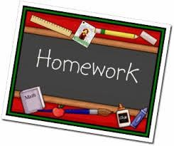
Yr 1 & 2 10 – 15 mins per school night
Yrs 3 & 4 15 – 20 mins per school night
Yrs 5 & 6 20 – 30 mins per school night

Normally teachers will outline their homework procedures at their Parent/Teacher information meeting held in February of each year. Teachers are encouraged to use the homework grid, which allows for both compulsory and optional activities as well as valuing the many commitments students have outside the school. Parents are expected to support teachers in their supervision of homework.

Homework is expected to be completed appropriately and at a high standard. It is the teachers’ responsibility to ensure homework is marked and returned within an appropriate timeframe. In the event that homework becomes difficult, parents are asked to communicate these difficulties to the class teacher. Homework should be an opportunity to reinforce known concepts, with a particular focus on literacy (in the early years). Should difficulties with time occur please let the teachers know. Homework should not be an unpleasant experience for parents or children.

LEARNING SUPPORT
The classroom teacher is responsible for the education of all students in his / her class utilising the support of appropriate personnel. Learning support applies to both students who need extension and intervention / remediation. Therefore it may be necessary for students who are early achievers as well as those who are experiencing difficulty.

Sue Chalk and Sally Hagley are the Learning Support Teachers (LST) within St Joseph’s. The LST provides expertise, resources, testing support, co-ordinate the Learning Support Teacher Assistants and acts as Case Manager for students with exceptional needs.

The learning support process:
*teacher identifies a student that needs assistance or a child’s parent discusses issues with classroom teacher
*teacher completes a teacher request form
*teacher provides a copy of form to learning support teacher and principal (parents are informed)
*learning support teacher observes child in the classroom situation
*learning support teacher and classroom teacher discuss strategies (meet with parents)
*based on LST recommendations, the classroom teacher either continues to implement strategies and support at a classroom level or begins further assessment process (form 1 and form 2 to be completed under the guidance of LST)
*Teachers will keep records of the support and strategies that they have in place. Depending on the level of support required some children may be on a modified program. These modifications are done with parents’ knowledge and the report card will reflect these modifications.
REPORTING
TO WHOM | HOW | WHY | WHEN
Student | □ verbal conference & written feedback | - to review documented progress  - to review self-assessment | □ when needed and appropriate
Parents/  Caregivers | □ parent/teacher information evening | - to allow both teacher and parents to become acquainted  - for teachers to give an overview of the curriculum program for the year | □ the beginning of the school year in the first couple of weeks
Parents/  Caregivers | □ parent/teacher interview | - to refer to evidence of skills acquired, work quality, strengths and difficulties  - to discuss academic, and non-academic development  - to set goals for the following term | - end of Terms 1 & 3 – compulsory  - as necessary
Parents/  Caregivers/ School | □ written report | - to refer to all documented assessments  - to identify areas of strength, progress and difficulty  - to report demonstration of curriculum learning | □ end of each semester and to be copied and added to student's folio

SPECIALIST AREAS 2022
Numeracy/Problem Solving Skills, The Arts and PE/Health

SWIMMING
Swimming is held at the Biloela Swimming Pool during Term One and Term Four. A timetable is organised for each term by the Sports Coordinator, in negotiation with the pool lessee.

SPORTS HOUSES
The students will be allocated a house team Gold (Kilburnie), White (Greycliffe) and Blue (Torsdale). Students will be encouraged to develop loyalty to their team. A boy and girl from Year 6 will be appointed as Captains of these houses each year.

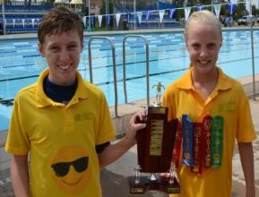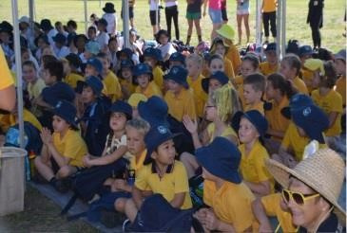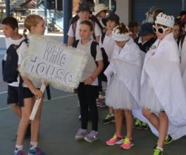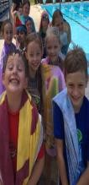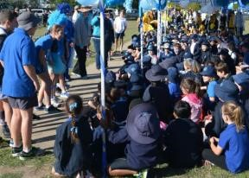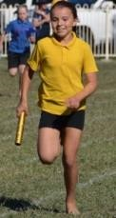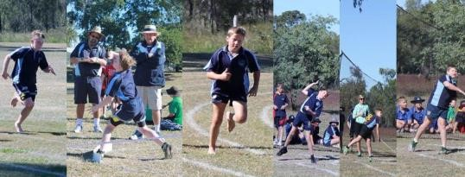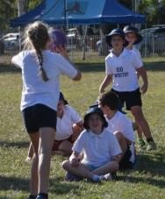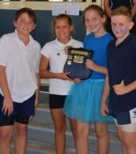
RESTORATIVE PRACTICES
At St Joseph’s we believe in promoting and encouraging healthy relationships between all stakeholders in our community – staff, students and parents. Our vision is for the St Joseph’s School community to be characterised by the compassion of Catherine McAuley and the Sisters of Mercy in our relationships with each other.
Conflict is a part of life, but how we respond to it sets us apart as followers of Christ. As a Catholic school, we are committed to following a Restorative Practices model; a pastoral approach to healthy relationships, not a behaviour management program. This relationship model views conflicts as learning opportunities where everyone works together to repair harm and fix relationships. If there is a problem, there is a process that is followed to foster awareness in the students of how others have been affected by their actions. This approach to conflict resolution promotes resilience in both the one harmed, and in the one who causes harm. Restorative Practices also places emphasis on the strength and potential in each student by helping them take responsibility for their behaviour. The desired outcome is stronger, more effective relationships.

How do we, as teachers, know we are being restorative?
- We teach WITH the students not just TO them – we use circle discussions and we are comfortable talking as a group.
- We use an explicit restorative approach to deal with problems.
- We use language that focuses on the effects of behaviours and repairing relationships, not on deciding what or who is right or wrong.
- When children have caused harm, they have the opportunity to tell their side of the story and are expected to talk about fixing the problem with those who are hurt.
- When students are hurt or offended, they have the opportunity to express that and do not avoid or deny how they feel and what they need.

When issues arise in the classroom or playground, we ask these three questions:
- What happened?
- Who has been affected?
- How can we fix it?

Restorative Practices is an active ministry of reconciliation, and St Joseph’s commitment to this model expresses the aims and objectives of our Catholic ethos. It is a practical means available to all of us to live the Gospel values of compassion, forgiveness, reconciliation and hope.

COMMUNICATION

WELCOME
All parents are welcome at the school anytime throughout the school year. It is appreciated if parents would sign in through the front office when arriving and leaving the school premises only if you are volunteering in the classroom or for tuckshop. This ensures we meet with the workplace, health and safety requirements for fire evacuation procedures. All teachers are asked to notify parents as to when volunteer help is required in the classroom. Sometimes these days and times don’t suit parents due to other commitments. Please see your child’s classroom teacher if you are able to help at any time. Some alternative arrangement could be made with the classroom teacher. Your help is always appreciated!

APPOINTMENTS WITH TEACHERS
Parents are encouraged to maintain contact with class teachers for the purpose of discussing their children’s progress. Consideration should be given to minimising disruption to core teaching time by seeking appointments outside class times. Appointments with the teaching staff may be obtained either directly by email or by contacting the school office.

SCHOOL RECORDS
Please ensure you keep the school up to date of any change of details. The information below is most important:
 | Change of address
 | Change of telephone contact numbers
 | Change of emergency contacts
 | Change of family doctor or dentist
 | Serious health conditions

INFORMATION EVENINGS
A parent information meeting is held during the first few weeks of 1st term to inform parents of expectations, homework, work to be covered, ways they can support / assist during the week and other relevant information.

FORTNIGHTLY CLASS NOTES
The classroom teachers are responsible for sending home fortnightly class notes. The purpose of these notes is to inform parents about what is happening in the classroom for that fortnight.

NEWSLETTER
The school newsletter link is distributed every second Tuesday via e-mail to every family and is also available on the school website and posted to St Joseph’s Facebook account.
Any notices for the newsletter need to be handed or emailed to the Principal or Administration Officer by Friday afternoon or Monday morning by 10am at the latest.

The APC and APRE will always present a newsletter item.

STAFF MEETINGS
Staff meetings are held weekly on Wednesday from 3.15pm and conclude no later than 4.30pm except by general agreement to continue a matter at hand. On occasions the staff meeting may be held on a different day to cater for local needs of visiting personnel. As much advance notice as possible is provided in such instances.
It is appreciated if parents are aware of this afternoon as teachers will not be available.

WORKPLACE HEALTH & SAFETY
St Joseph’s School operates in accordance with the Diocesan Policy Statement.

ASTHMA REGISTER
An Asthmatic Register is maintained in the office. Teachers should familiarise themselves with any children in their class who may be Asthmatics. Parents are required to provide the school with an action plan for their child if they suffer from Asthma.

EVACUATION POLICY
The continuous ringing of the school bell indicates the need to evacuate.
An Evacuation Drill takes place at least once per term. The evacuation plan is located in all rooms. Please familiarise yourself with its location and the path to be followed.

All classes will assemble on the oval.

Each teacher is responsible for making certain all students are located in the designated areas by -
I. Walking the students in an orderly manner to the designated area.
II. Taking the class roll to the designated area and having a roll call.
- Informing Principal/APRE/APC/Secretary of any students not present.
- Keep students assembled until further notice from the Principal, APRE/APC or Secretary.

Class teachers will take a copy of class rolls and the school secretary the emergency folder to the assembly area. The Principal/APRE/APC/Secretary will be responsible for checking the assembled classes to ensure all students are located.

The Principal/APRE/APC/Secretary records the evacuation details in the EVACUATION REGISTER.

Parents need to be aware of this process if they are helping in the classrooms.

EXCURSIONS
Parents are always welcome to help with excursions. Please ask the classroom teacher for details of the event.

Parents must have completed the Volunteer Induction to be able to accompany students on excursions.

SCHOOL CAMPS
School Camps are an important learning and socialising experience and are part of our school curriculum for year 5 and 6. Camp is not meant to be a holiday but an extension of the classroom into a different learning environment.

FIRST AID
The First Aid Kit is located in the Sick Room. A portable First Aid Kit used for excursions and times when students leave the school grounds is kept in Sick Bay. The Prep room maintains a minor First Aid Kit of band aids etc for minor incidents.

There are multiple staff members that are the first aid officers. However, parents are always notified by phone of any incidents.

All treatment of individuals is recorded in the School First Aid Register by the person treating the individual. In the case of serious incidents the teacher who witnessed (or received the report of the accident/injury) will complete a Riskman Report.

All staff members are encouraged to gain their First Aid qualifications.

HATS
The School hat is navy blue with the school logo imprinted on the front. Children are to wear hats at all times when outside the classroom.

Children without hats must remain in the covered lunch area.
NO HAT NO PLAY.

SUNSCREEN
Sunscreen is available in bulk for each class. It is the teacher’s responsibility to promote the wearing of this with outside activities. This does not mean physically applying it to each child, but rather making it available and emphasising that it should be applied.

DISCIPLINE
SCHOOL RULES
Respect Yourself, Respect Others and Respect the Environment.

BEHAVIOUR MANAGEMENT PLAN
A copy of the school behaviour management plan is available on request.

SCHOOL UNIFORM
The students at St Joseph’s School have an excellent reputation for valuing and respecting the traditions of the school community. It is essential for the unity of the school that the school uniform, as an external expression of these values and respect, is worn correctly and with pride.

DAY UNIFORM: Girls
Skorts: Navy embroidered with SJB
Blouse: Check blouse with navy collar and emblem
DAY UNIFORM- BOYS
Shorts: Navy embroidered with SJB
Shirt: Blue formal button shirt
SPORTS UNIFORM (BOYS AND GIRLS)
Shirt: Navy blue front panel with light blue sides with navy collar, emblem on front left
Shorts: Navy as for day uniform

The following items are worn with all uniform variations by Boys and Girls:
Hat: Bucket hat, navy blue with emblem
Socks: Short Navy blue
Shoes: Black, Lace up leather (all distinguishing colour features to be blacked out)

Winter: Navy blue jackets or jumpers
Availability: All uniforms are purchased from LOWES Rockhampton.
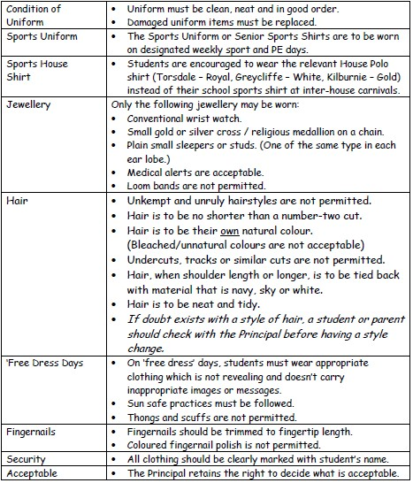
St Joseph’s Catholic Primary School Biloela Presentation Code

